Supplementary material

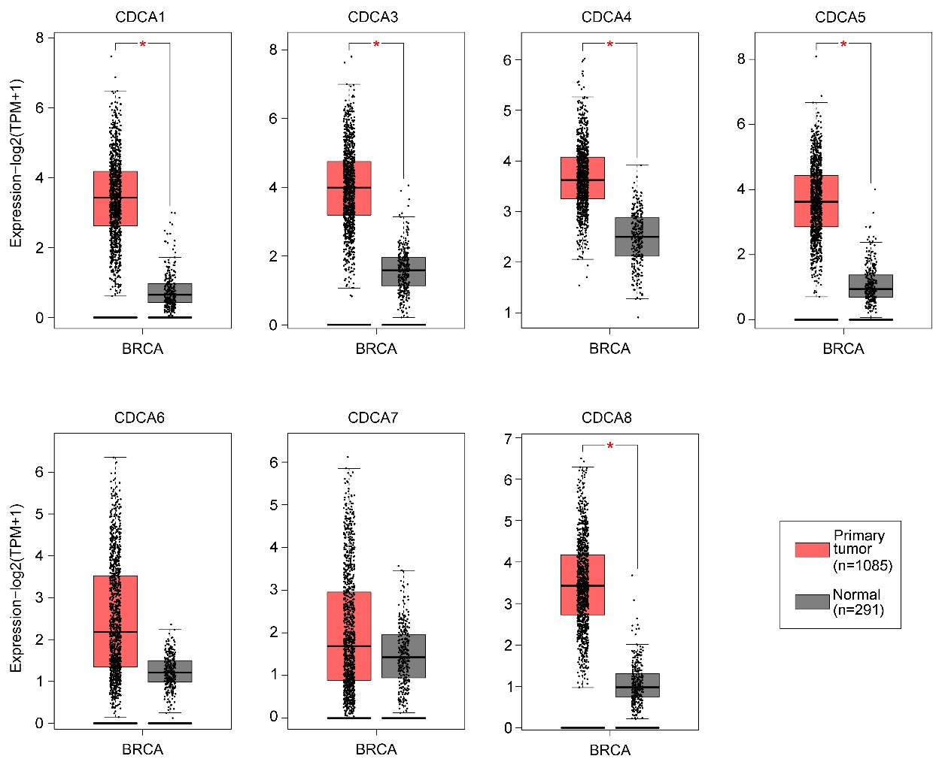
Supplementary Fig. 1. The transcriptional levels of CDCAs in breast cancer tissue (GEPIA). CDCA: cell division cycle associated; BRCA: Breast Cancer Gene; TPM: Transcripts Per Kilobase of exon model per Million mapped reads.

